THE WALL STREET JOURNAL
TUESDAY, APRIL 28, 2009 17

CAREER JOURNAL

Jobless? Start a layoff-related business

Entrepreneurs find ways to capitalize on their plight

BY ALINA DIZIK

The same day that Stephanie Aucoin was stopped in an elevator wearing her new yellow wristband with “Laid Off Need a Job.com” embossed with black letters, she got a job offer to be assistant to the chief financial officer at an alternative energy company.
The executive saw her bracelet and told her to stop in to meet with him. “I did,” says Ms. Aucoin, 48, who started the new job in March after being laid off from an executive assistant position at a local accounting firm last September.
The silicone bracelet–think Lance Armstrong’s Livestrong original version but with prominent black lettering–was an idea Ms. Aucion, of Savasota Fla., came up with Barbara Bourn, 59, a former colleague.
Hopeful entrepreneurs, most who’ve lost their jobs, are capitalizing on others like them–while also highlighting the plight of the jobless. They are dreaming up layoff–related merchandise, offering wristbands, mugs, T-shirts, board games and more to the recently unemployed, whose ranks in the U.S. alone are growing with more than 5.1 million jobs lost so far since December 2007 and more expected to be lost in the coming months.
And invention has meant money to pad dwindling savings. That’s what originally motivated Ms. Aucoin and Ms. Bourn. “We needed to find a gimmick (to earn money),” says Ms. Bourn, who was forced to sell her house after her hours in an interior design sales position were cut back. The idea of the bracelets came after Ms. Aucion had depleted her entire savings and still had not had a job interview. The two women thought starting their own business might be the only way to earn a living, so they began to brainstorm ideas until the wristband came up. “We researched the cost and decided it was doable for our budget,” says Ms. Aucoin.
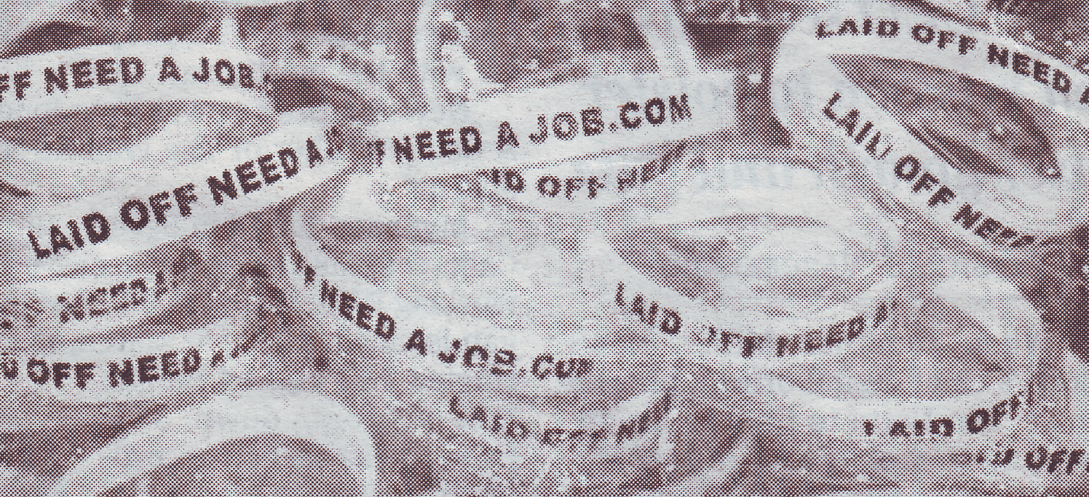
Ms. Bourn used $1,000 of her sayings to invest in the business, and Ms. Aucoin built a Web site for the product. The pair found a manufacturer that would customize the bracelets and ordered 500 Laid Off bracelets. Within weeks, the pair launched the Web site laidoffneedajob.com and began hawking the wristbands for $3 each. They used Ms. Bourn’s apartment as a make–shift mail depot while spreading the word about their venture via social–networking site Twitter, which helped spark sales. Last week, the Web site averaged 500 visitors per day. With about five weeks in business, the pair has sold 4,500 bracelets, broken even on their investment and pocketed $8,900.
Jim Hart, a former sales manager for pharmaceutical equipment company in Arlington, Texas, ordered three bracelets after seeing someone else walking around with one at an airport. So far, it has stirred interest. “Just by seeing this, people start asking ,e questions,” he says. And one of his bracelet-wearing friends has already landed an interview.
Other entrepreneurs have been stepping in with their own offbeat ideas for the laid off. After seeing his freelance contracts as a benefit coordination for insurance companies disappear, Daniel Brabson, 38, launched RecessionJunction.com. The site sells beer mugs T-shirt and bumper stickers with humorous saying about the economy and layoffs.
A coffee mug with ‘Alms for the Poor’ written on it and pint glass that says ‘This Beer is Going Down Like the Stock Market’ have been best

sellers. “I just hope (people) are able to kind of laugh at themselves it’s though for a lot of people, “say Mr. Brabson, who took out a $3,000 bank loan to start the business and launched the site in February. He uses several local vendors to customize designs for each product. Mr. Branson is hopeful that he’ll break even in the the next two months and so far he has sold 150 items, which priced between $4 and $14 each.
Other who’ve started their own layoff-related businesses have seen an increase in interest. After his own layoff in 2005, Larry Dinsmore, an IT professional, started a web site called Damn I Need a job, which offers T-shirts with a customer’s cover letter

printed on it. Each customized T-shirt cost $25. Mr. Dinsmore, who is now employed, says web site traffic has increased by about 30% in the past few months, but that sales are steady. “The target audience doesn’t have a lot of money to blow,” he muses.
As for the bracelet venture, Ms,Aucoin and Ms.Bourn are focused on growing the business. Right now, neither ere bangking on an upturn and, even when that comes, their pair don’t have plants to change the bracelet’s message. “We just want to get everyone to wear one,” says Ms.Bourn.

